Advanced Interpolation, User Guide

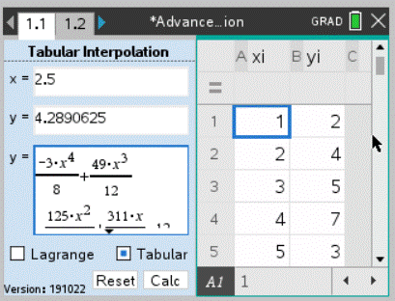
Main Window 1.1
2
1
3
4
How to perform calculations
- Start by selecting preferred interpolation method. (It is also possible to use Tab key or the menu button on the hand held unit.)
  - Lagrange interpolation creates a polynomial for calculating y from a given x based on minimum three given points.
  - Spline interpolation creates a piecewise polynomial for calculating y from a given x based on minimum three given points. (The spline is a natural cubic spline).
  - Tabular interpolation uses either three or five given points to calculate y from a given x. The application will automatically choose between three or five tabular method depending on table length.
- Enter known points into table xi,yi.
  - All xi values must be unique!
  - Lagrange and spline interpolation requires minimum three given points to complete calculation. Maximum recommended given points are ten. Tabular interpolation requires either three or five given points for calculations.
  - When using tabular interpolation all xi values must be evenly distributed. Lagrange and spline interpolation does not require evenly distributed xi values.
  - When using tabular or spline interpolation all xi values must be sorted in ascending order.
- Enter value x for which value y shall be calculated. Press Calc button or Enter key to complete the calculation.
  - When using tabular interpolation the given x must be between centre xi value and nearby xi value. From above example x must be between 2 and 4 for conducting tabular calculations.
  - When using Lagrange or spline method x must be within the range of table xi.
- The top y-box displays the calculated value of y from given x. Bottom y-box displays the equation used for calculating y.
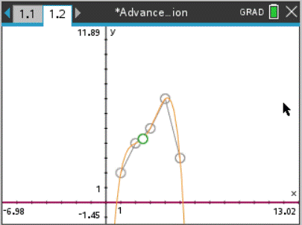

5

Graph Window 1.2
- Go to page 1.2 to view the graph plotted for latest calculation. Page 1.2 is a standard Nspire graph page, so for further details on how work with graphs, see TI’s user manual.
  - Black point, shows the calculated y and given x.
  - Gray points, shows the points entered in table xi,yi.
  - Orange graph, shows the function calculated from 5 tabular points.
  - Red graph, shows the function calculated from 3 tabular points.
  - Blue graph, shows the function calculated with Lagrange Interpolation method.
  - Green graph, shows the function calculated with Lagrange Interpolation method.

Notes
- Reset button removes all data from application. It is also possible to make reset by pressing Esc key two times quickly.
- Program scale to fit all resolutions. Minimum resolution is 212 x 318 px used by hand held unit. Horizontal split or any other custom split view other than the default is not supported.
- If further calculations is needed, the functions used to display the graphs are stored in variables lagrangefunction, tabular3function, tabular5function and splinefunction.
- The Lua script is password protected. However, the password to the script is the version number displayed in bottom left corner on page 1.1.

/Fredrik Ekelöf, fredrik.ekelof@gmail.com

